Title or Task: |   

Description:

Files Required
Suitable for Classes: | AIT • Multimedia • Cert II IT • Cert II Bus
Area: | Technology & Enterprise
Teacher: | Mr Peter Faulks

Timeline

Date Due:
Task Brief: | In class lesson

Outcomes:

SOLUTIONS
See completed page
http://peterfaulks.net/Teaching/Student_Compendium/SC007_Commonly_confused_words.htm

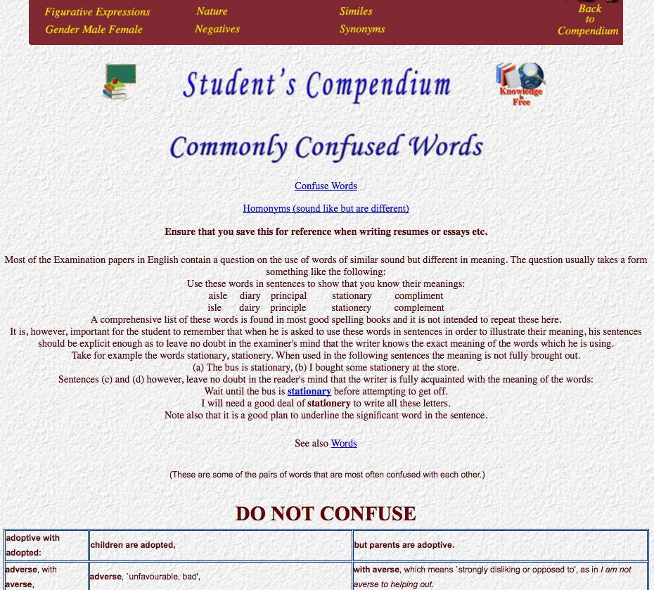

Ensure that you save this for reference when writing resumes or essays etc.

Method 1 create a table with 3 Colums and 50 rows, drag text to the appropriate Colum and row.

Method 2 put a tab after each part of the row below then highlight all and Convert text to table using Tab as the separator, go through the table and correct errors.

(These are some of the pairs of words that are most often confused with each other.)

adoptive with adopted: (tab) children are adopted, (tab) but parents are adoptive.

adoptive with adopted: | children are adopted, | but parents are adoptive.
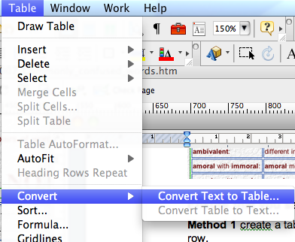

DO NOT CONFUSE
adoptive with adopted: children are adopted, but parents are adoptive.
adverse, `unfavourable, bad', with averse, which means `strongly disliking or opposed to', as in I am not averse to helping out.
affect and effect: affect means `make a difference to', whereas effect means `a result' or `bring about (a result)'.
ambiguous with ambivalent: ambiguous primarily means `having more than one meaning, open to different interpretations', while ambivalent means `having mixed feelings'.
amoral with immoral: amoral means `not concerned with morality', while immoral means `not conforming to accepted standards of morality'.
appraise with apprise: appraise means `assess', while apprise means `inform'.
augur, `be a sign of (a likely outcome)', with auger (a tool used for boring).
censure with censor: censure means `express strong disapproval of', whereas censor means `suppress unacceptable parts of (a book, film, etc.)'.
climactic, `forming a climax', with climatic, which means `relating to climate'.
complacent, `smug and self-satisfied', with complaisant, which means `willing to please'.
complement, `a thing that enhances something by contributing extra features', with compliment, which means `an expression of praise' or `politely congratulate'.
continuous and continual: continuous primarily means `without interruption', and can refer to space as well as time, as in the cliffs form a continuous line along the coast; continual, on the other hand, typically means `happening frequently, with intervals between', as in the bus service has been disrupted by continual breakdowns.
council, an administrative or advisory body, with counsel, advice or guidance.
councillor with counsellor: a councillor is a member of a council, whereas a counsellor is someone who gives guidance on personal or psychological problems.
credible with creditable: credible means `believable, convincing', whereas creditable means `deserving acknowledgement and praise'.
definite (`certain, sure') with definitive, which means `decisive and with authority'.
defuse, `remove the fuse from (an explosive device)' or `reduce the danger or tension in (a difficult situation)', with diffuse, which means `spread over a wide area'.
desert (a waterless area) with dessert (the sweet course)!

discreet, `careful not to attract attention or give offence', with discrete, which means `separate, distinct'.
draft and draught. In British English draft means `a preliminary version' or `an order to pay a sum', whereas a draught is a current of air or an act of drinking; in North American English the spelling draft is used for all senses. The verb is usually spelled draft.
draw, which is primarily a verb, with drawer meaning `sliding storage compartment'.
egoism and egotism: it is egotism, not egoism, that means `excessive conceit or self-absorption'; egoism is a less common and more technical word, for an ethical theory that treats self-interest as the foundation of morality.
envelop with envelope: envelop without an e at the end means `wrap up, cover, or surround completely', whereas an envelope with an e is a paper container used to enclose a letter or document.
exceptionable (`open to objection; causing disapproval or offence') with exceptional (`not typical' or `unusually good').
fawn with faun: a fawn is a young deer, and a light brown colour; a faun is a Roman deity that is part man, part goat.
flaunt with flout; flaunt means `display ostentatiously', while flout means `openly disregard (a rule)'.
flounder with founder: flounder generally means `have trouble doing or understanding something, be confused', while founder means `fail or come to nothing'.
forego and forgo: forego means `precede', but is also a less common spelling for forgo, `go without`.
grisly with grizzly, as in grizzly bear: grisly means `causing horror or revulsion', whereas grizzly is from the same root as grizzled and refers to the bear's white-tipped fur.
hoard with horde: a hoard is a store of something valuable; horde is a disparaging term for a large group of people.
imply and infer. Imply is used with a speaker as its subject, as in he implied that the General was a traitor, and indicates that the speaker is suggesting something though not making an explicit statement. Infer is used in sentences such as we inferred from his words that the General was a traitor, and indicates that something in the speaker's words enabled the listeners to deduce that the man was a traitor.
the possessive its (as in turn the camera on its side) with the contraction it's (short for either it is or it has, as in it's my fault; it's been a hot day).

loath (`reluctant; unwilling') with loathe, `dislike greatly'.
loose with lose: as a verb loose means `unfasten or set free', while lose means `cease to have' or `become unable to find'.
luxuriant, `rich and profuse in growth', with luxurious, which means `characterized by luxury; very comfortable and extravagant'.
marital, `of marriage', with martial, `of war'!
militate, which is used in the form militate against to mean `be an important factor in preventing', with mitigate, which means `make (something bad) less severe'.
naturism (nudism) and naturist (a nudist) with naturalism and naturalist: naturalism is an artistic or literary approach or style; a naturalist is an expert in natural history, or an exponent of naturalism.
officious, `asserting authority or interfering in an annoyingly domineering way', with official, which means `relating to an authority or public body' and `having the approval or authorization of such a body'.
ordinance, `an authoritative order', with ordnance, which means `guns' or `munitions'.
palate and palette: the palate is the roof of the mouth; a palette, on the other hand, is an artist's board for mixing colours.
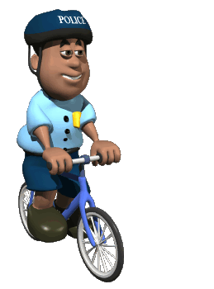
pedal and peddle. Pedal is a noun denoting a foot-operated lever; as a verb it means `move by means of pedals'. Peddle is a verb meaning `sell (goods)'. The associated noun from pedal is pedaller (US pedaler), and the noun from peddle is pedlar or peddler.
perquisite and prerequisite: a perquisite is a special right or privilege enjoyed as a result of one's position; prerequisite is something that is required as a prior condition for something else; prerequisite can also be an adjective, meaning `required as a prior condition'.
perspicuous, `expressing things clearly', with perspicacious, which means `having a ready understanding of things'.
principal, `first in order of importance; main', with principle, which is a noun meaning chiefly `a basis of a system of thought or belief'.
proscribe with prescribe: proscribe is a rather formal word meaning `condemn or forbid', whereas prescribe means either `issue a medical prescription' or `recommend with authority'.
regretful, `feeling or showing regret', with regrettable, which means `giving rise to regret; undesirable'.
shear, `cut the wool off (a sheep)', with sheer, which as a verb means `swerve or change course quickly' or `avoid an unpleasant topic', and as an adjective means `nothing but; absolute', `perpendicular', or `(of a fabric) very thin'.
stationary and stationery: stationary is an adjective with the sense `not moving or changing', whereas stationery is a noun meaning `paper and other writing materials'.
story and storey: a story is a tale or account, while a storey is a floor of a building. In North America the spelling story is sometimes used for storey.
titillate and titivate: titillate means `excite', whereas titivate means `adorn or smarten up'.
tortuous, `full of twists and turns' or `excessively lengthy and complex', with torturous, which means `characterized by pain or suffering'.
turbid and turgid: turbid is generally used in reference to a liquid and means `cloudy or opaque'; turgid tends to mean `tediously pompous' or, in reference to a river, `swollen, overflowing'.
unexceptionable, `that cannot be taken exception to, inoffensive', with unexceptional, `not exceptional; ordinary'.
unsociable with unsocial and antisocial: unsociable means `not enjoying the company of or engaging in activities with others'; unsocial usually means `socially inconvenient' and typically refers to the hours of work of a job; antisocial means `contrary to accepted social customs and therefore annoying'.
venal (`susceptible to bribery; corruptible') with venial, which is used in Christian theology in reference to sin (a venial sin, unlike a mortal sin, is not regarded as depriving the soul of divine grace).
who's with whose; who's is a contraction of who is or who has, while whose is used in questions such as whose is this? and whose turn is it?
wreath and wreathe: wreath with no e at the end means `arrangement of flowers', while wreathe with an e is a verb meaning `envelop, surround, or encircle'.
your with you're; you're is a contraction of you are, while your is a possessive determiner used in phrases such as your turn.



